# Pet Adoption Center

**Course: Front End UI/UX**

**Institute: Christ University**

**Group Members:**

**Sricharan A – 2462532 – sricharan.a@btech.christuniversity.in**

**Anirudh VO – 2462536 – vo.anirudh@btech.christuniversity.in**

**Swara Madichedi – 2462533 – swara.madichedi@btech.christuniversity.in**

**____________________________________________________________________________________________________**

## 1. Project Overview

This project is a responsive website for a fictional Pet Adoption Center. It displays available pets, describes the adoption process, showcases success stories, and provides a volunteer application form. The site is static, built using semantic HTML5 and modern CSS techniques including Flexbox. The goal is to create a friendly, accessible, and visually appealing platform to encourage pet adoption.

## 2. Objectives

• Create an engaging, user-friendly website to promote pet adoption.

• Apply semantic HTML and CSS for structure and design.

• Use Flexbox for responsive layout.

• Ensure the site works well on desktop and mobile devices.

## 3. Expected Outcomes

• Showcase pets available for adoption in a visually appealing way.

• Provide clear instructions for the adoption process.

• Offer a volunteer form for community engagement.

• Develop skills in building responsive static websites.

## 4. Pages & Design

Home — Introduction to the Pet Adoption Center and navigation menu.

Available Pets — Grid of adoptable animals with names, ages, and traits.

Adoption Process — Step-by-step guide to adopting a pet.

Success Stories — Positive stories from past adoptions.

Volunteer Form — Form for visitors to sign up as volunteers.

Footer — Social media links and copyright.

## 5. Design Choices

• Font: Arial for readability and friendliness.

• Color Palette: Soft pinks and cream for a warm, inviting feel.

• Layout: Flexbox for responsive arrangement of cards and content.

• Accessibility: Semantic tags, alt text for images.

• Responsiveness: Mobile-friendly design with flexible grid.

## 6. Technical Implementation

• HTML file: index.html (all sections included in one page).

• CSS file: css/style.css (single stylesheet for styling).

• Images stored in /images/ folder.

• No JavaScript used — purely HTML/CSS for simplicity and speed.

## 7. Screenshots:

**Available Pets:**

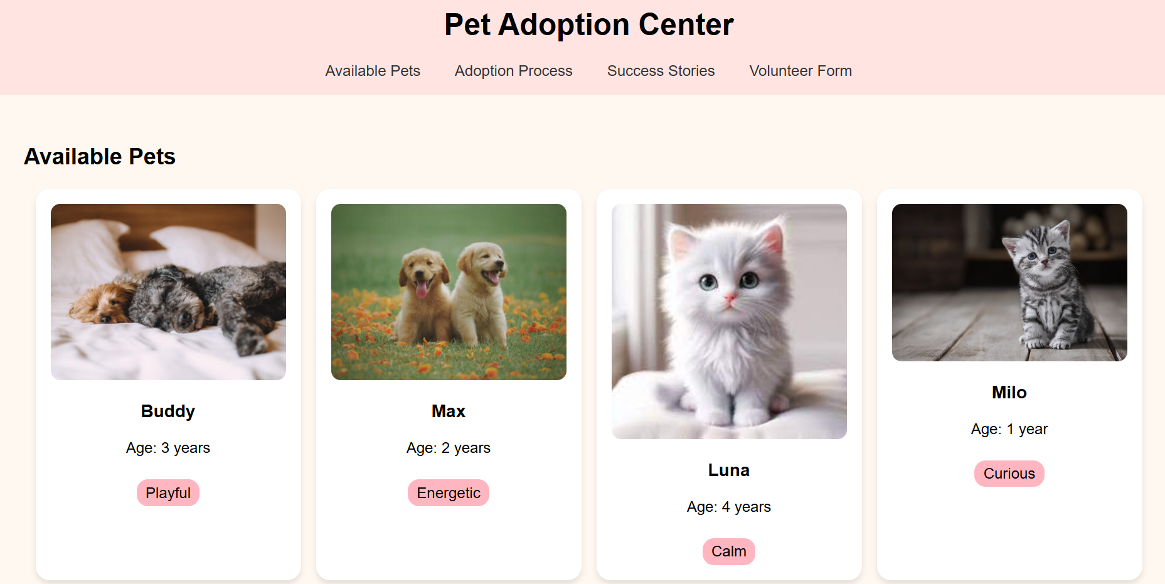

**Adoption Process:**

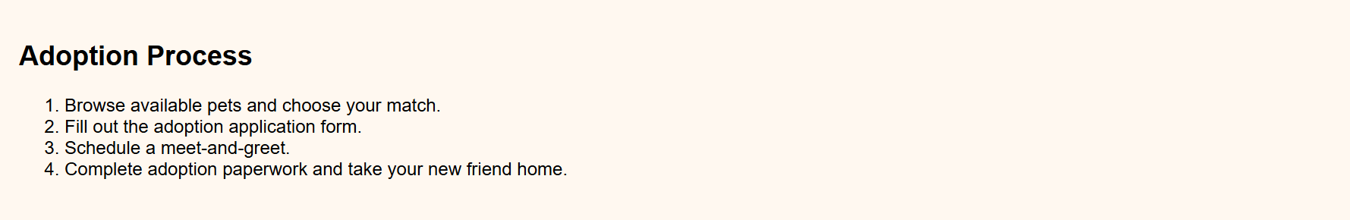

**Success Stories:**

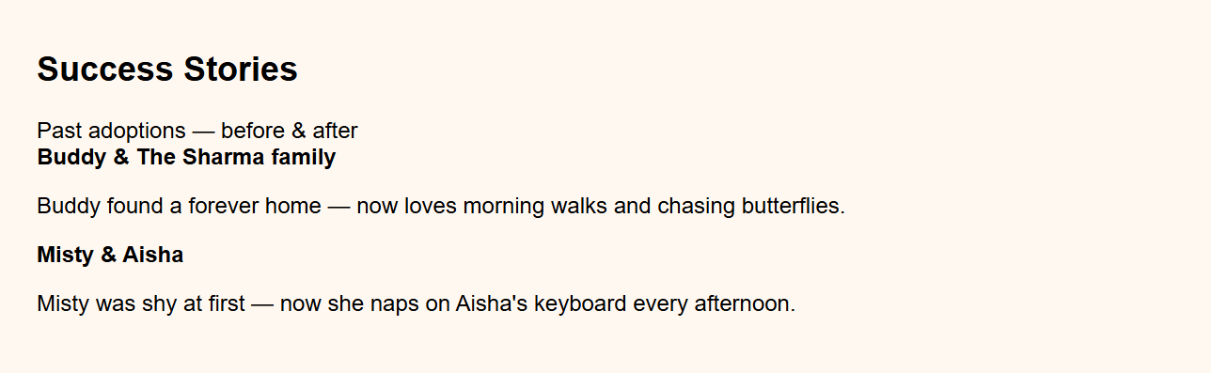

**Volunteer Form:**

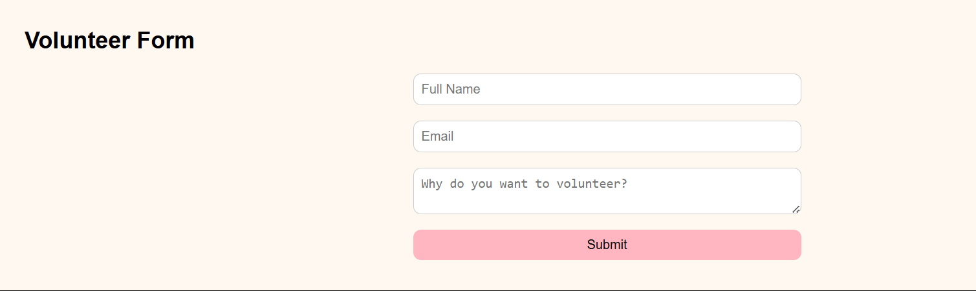

## 8. Group Roles & Contribution

Swara Madichedi — Main developer (HTML/CSS structure and responsiveness).

Anirudh VO — Content creator (text for process, stories, volunteer form).

Sricharan A — Designer (color palette, images, layout aesthetics).

## 9. GitHub & Submission

**Repository:** https://github.com/sricharan-abtech/Front-End-UI-UX-Webpage-Design

All HTML, CSS, images, and this project report are available in the repository.

## 10. Final Checklist

• Responsive design implemented with Flexbox.

• Semantic HTML structure used throughout.

• CSS styling consistent and clean.

• Images and content relevant to pet adoption.

• Project report included in repository.

• GitHub repository public and linked in submission spreadsheet.